**Fiverr Service Analysis Dashboard Report**

**Overview:**

This dashboard analyses buyer and seller data to offer insights into the Fiverr marketplace. The visuals emphasize:

1. Reviews from buyers in a variety of categories.

2. Price patterns for many categories.

3. Average ratings and prices.

4. Leading services and performance indicators for them.  
  
In order to help both consumers and sellers make wise selections, the objective is to educate them on popular services, pricing methods, and market trends.

**Data Preparation:**

To ensure the dataset was accurate, clean, and ready for analysis, the following steps were performed using Power Query Editor:

1. Renamed ambiguous or generic column names to clear and meaningful labels for better understanding.
2. Split columns by delimiters and position.
3. Replacing Values with other values or an empty space.
4. Converted data types to ensure consistency and proper functionality of visualizations.
5. Eliminated duplicate rows to avoid inflated results.
6. Removed irrelevant or incomplete entries to improve the accuracy of the analysis.

These steps were crucial in ensuring the data was clean, structured, and ready for visualization in Power BI.

**Objectives:**

1. Analyze reviews by buyers across Fiverr service categories.
2. Compare service categories based on pricing and popularity.
3. Identify top-performing services and their subcategories.
4. Provide key metrics like average reviews and prices to guide buyers and sellers

**Dashboard:**

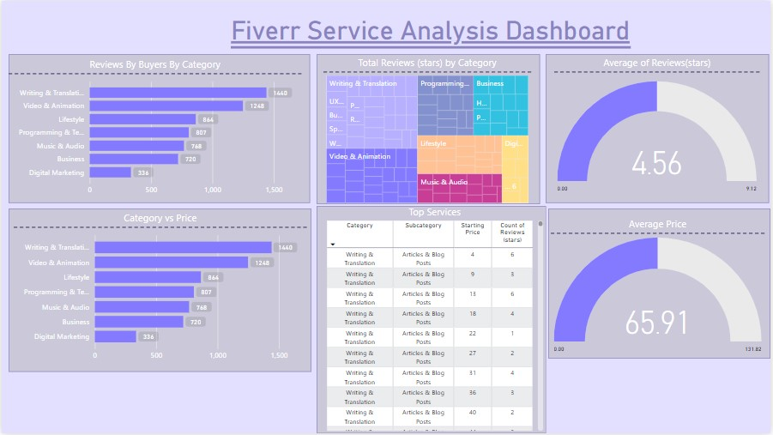

**Key Insights:**

**Question 1:** Which Fiverr categories have the highest number of buyer reviews?

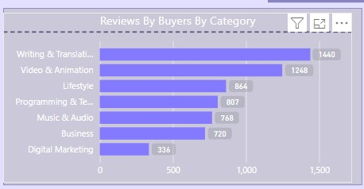

Top 3 Categories by Reviews:

* Writing & Translation: 1,460 reviews.
* Video & Animation: 1,248 reviews.
* Lifestyle: 864 reviews.

This indicates that Writing & Translation is the most reviewed category, highlighting its popularity among buyers.

**Question 2:** How do different categories compare in terms of price?

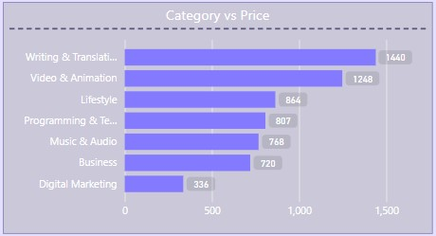

Categories like Writing & Translation and Video & Animation dominate not only in reviews but also in pricing.

Categories such as Digital Marketing have fewer reviews, suggesting they are less popular or targeted.

**Question 3:** What are the average review ratings and prices across all categories?

Gauges has been used for average reviews and prices.

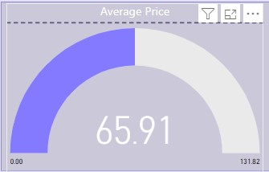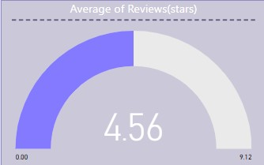

Average Review Rating: 4.56 stars.

Average Price: $65.91.

This suggests overall high satisfaction among Fiverr buyers and a moderate pricing trend.

**Question 4:** How are reviews distributed among Fiverr service categories?

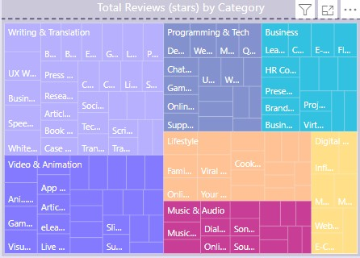

A Tree map is used to categorize the total reviews by category and sub category.

Categories like Writing & Translation and Video & Animation occupy the largest areas, further confirming their dominance.

Smaller areas such as Digital Marketing indicate fewer reviews and potentially lower demand.

**Conclusion:**

The dashboard provides a comprehensive view of Fiverr's buyer-seller dynamics, revealing:

1. Writing & Translation and Video & Animation are the most popular and well-reviewed categories.
2. Pricing varies significantly across categories, with an average of $65.91.
3. High satisfaction levels are evident from an average review rating of 4.56 stars.
4. Top-performing services belong to Writing & Translation, specifically Articles & Blog Posts, emphasizing the importance of content creation.

**Recommendations:**

Optimize pricing strategies around the average price point

Look for highly rated services with detailed reviews to ensure quality.

Use the average pricing as a benchmark to compare offerings.

Encourage new sellers to enter top-performing categories with competitive pricing.